New Measure

Description:
This is the developer tutorial for implementing a new measure. In this tutorial, we will explain how to create a new measure in braph2genesis. Here, we use the Degree as an example to show how to implement the calculation of the Degree.

File path:
\braph2genesis\measures\_Degree.gen.m

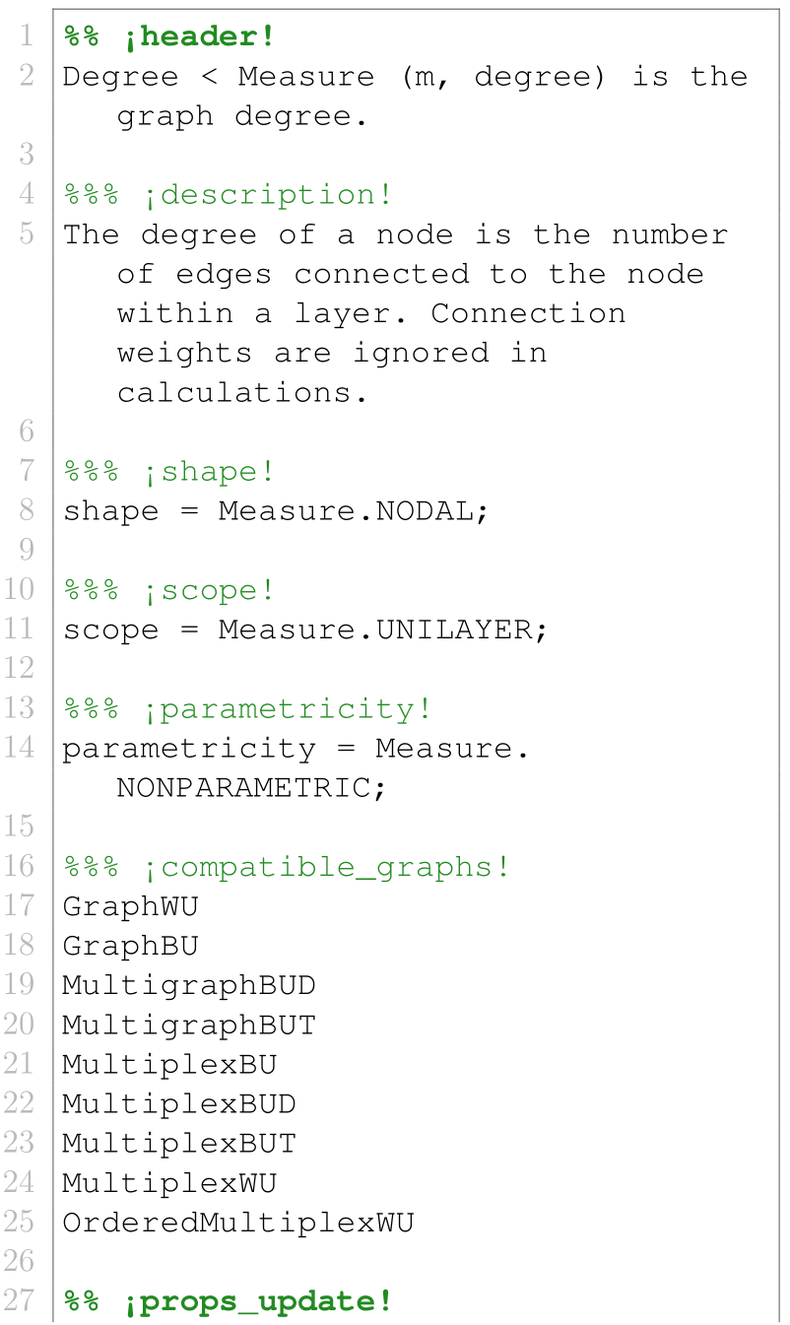
Code:
In header section, the class Degree is defined as a subclass of class Measure.

In description section, the definition of the Degree is annotated.

In shape, scope, scope, parmetricity, and compatible_graphs sections, the corresponding parameters are defined.

In props_update section, the inheritance properties are specified or calculated.

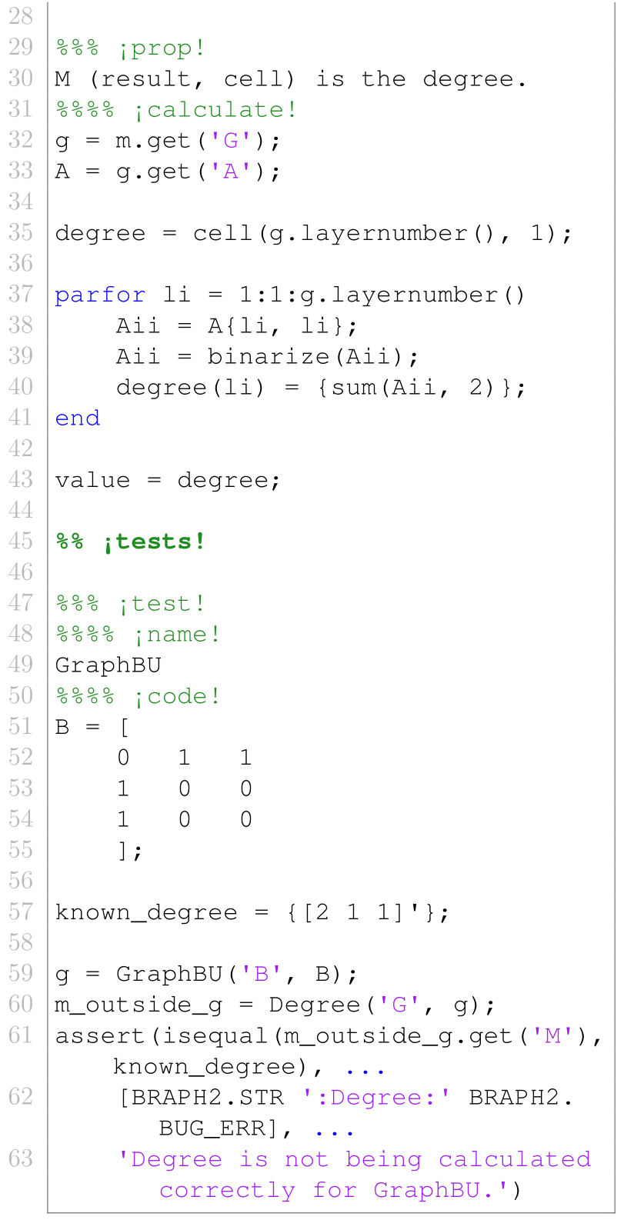

Here, the prop M is the calculated value of the Degree, which is the number of edges connected to the node within a layer.

In tests section, the unit test of the Degree is added.

