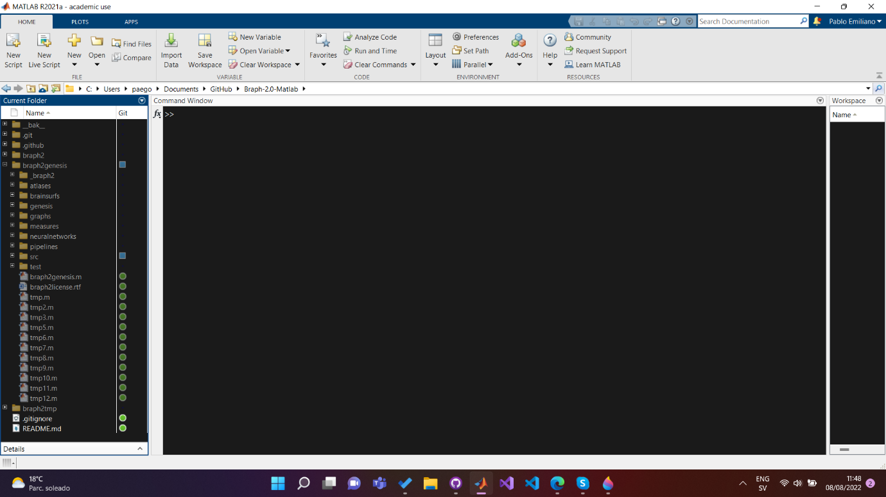
Once inside MATLAB go to the folder where you downloaded (and unzipped if needed) BRAPH 2. Run braph2genesis, you will need to add it to MATLAB’s path. BRAPH 2 will compile, and it will create a new folder BRAPH 2. This might take some time.
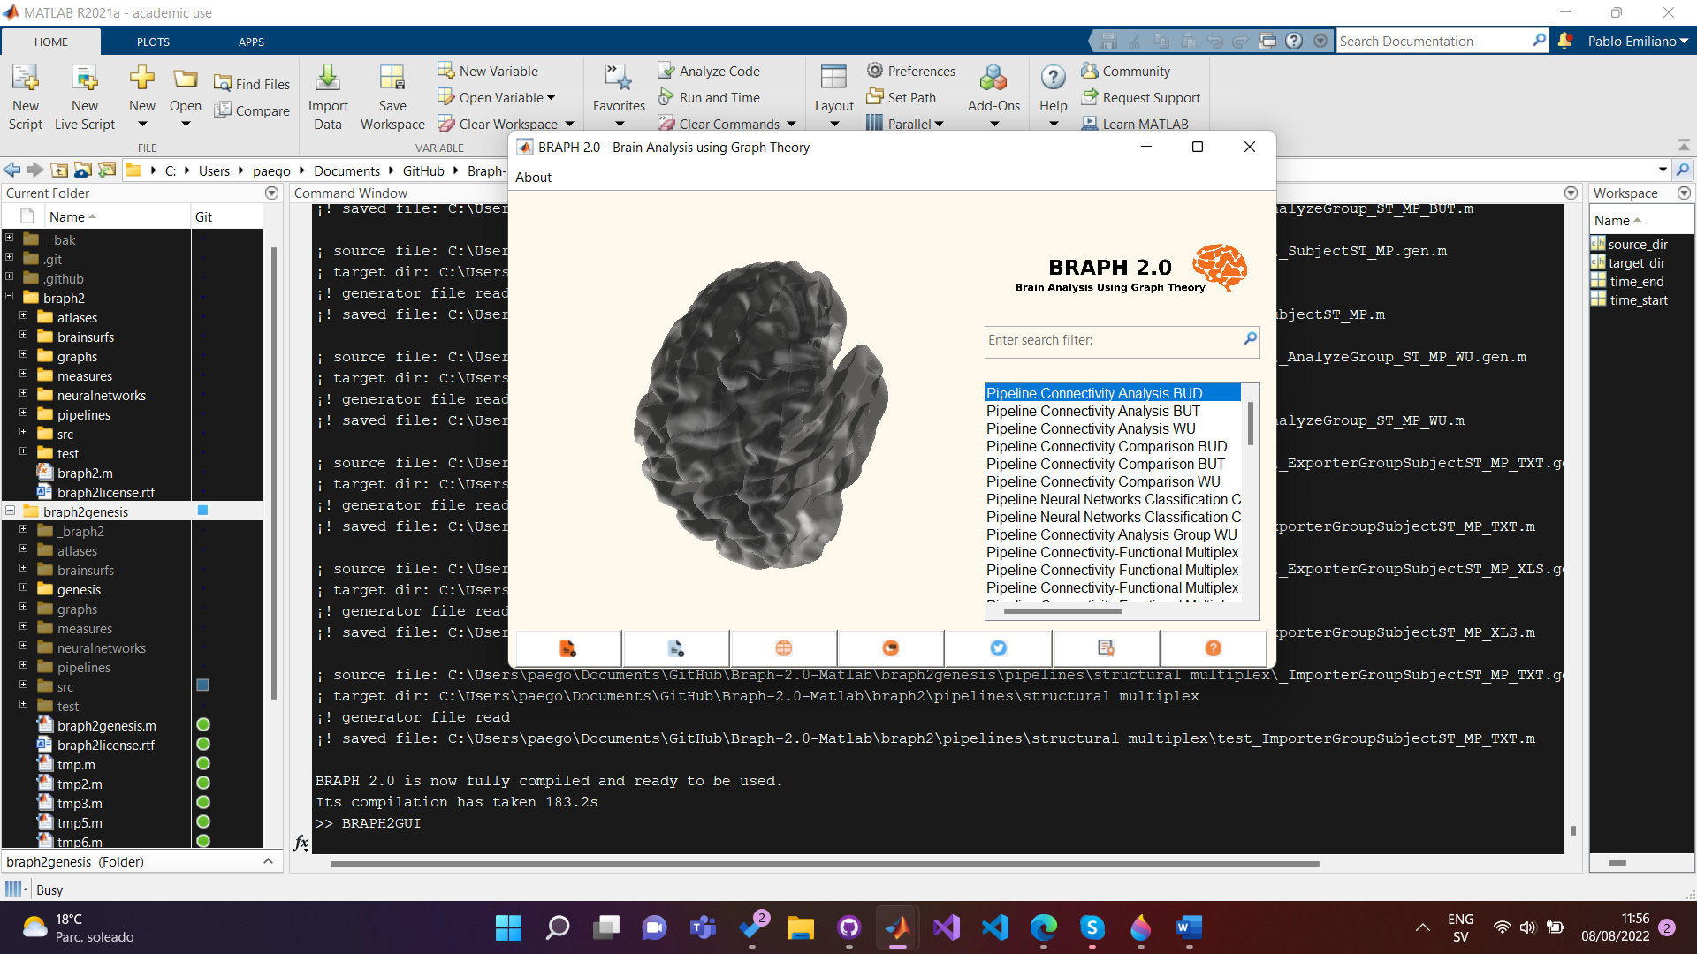
If the main window has not opened automatically, please use BRAPH2GUI command (notice that letter case is important). In this window select which case of analysis you need and double click on it. For DTI, it is common that you already have the adjacency matrices ready, so use the pipeline Connectivity. Please check the folder “example data CON (DTI)” inside the pipeline Connectivity to see BRAPH 2 atlas format and data format. As of today, you can import them to BRAPH 2 from txt, xlsx and json.
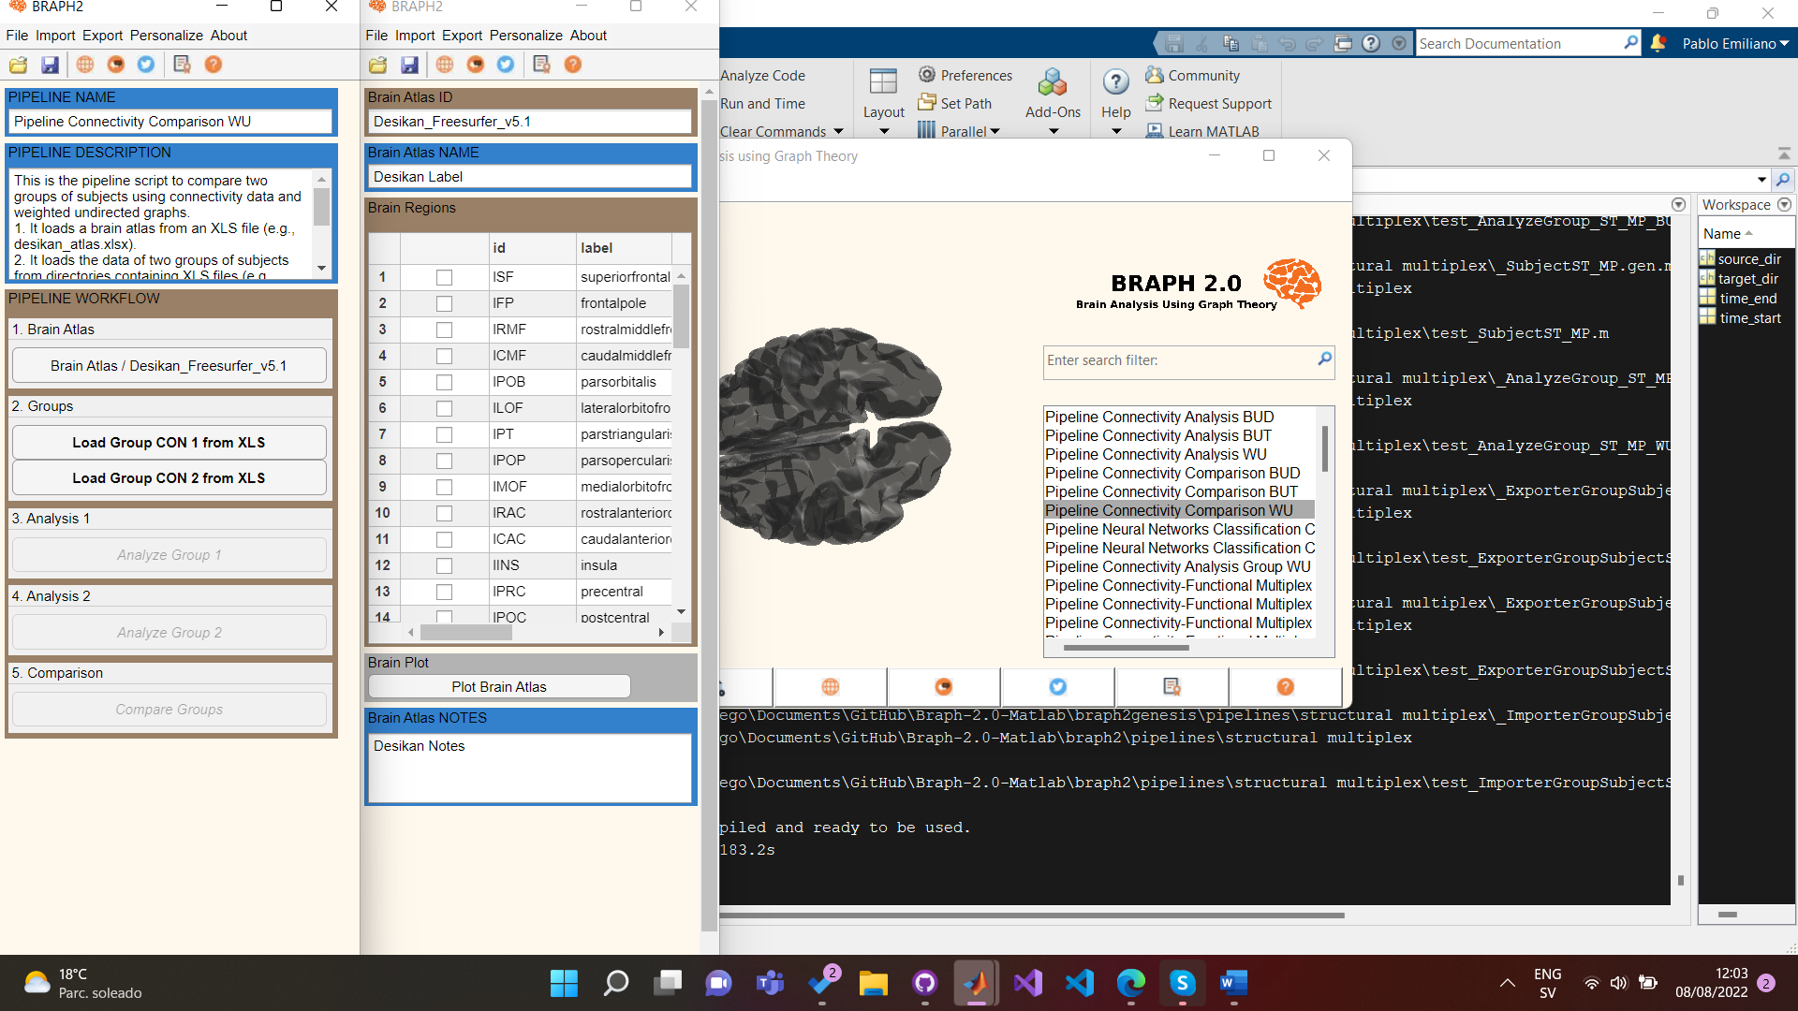
The pipeline will guide you through the steps needed to make the desired analysis. In this tutorial I will mock a comparison between two groups of subjects with DTI data. The first step is to load a brain atlas, We have used the one in the example folder “desikan_atlas.xls” .
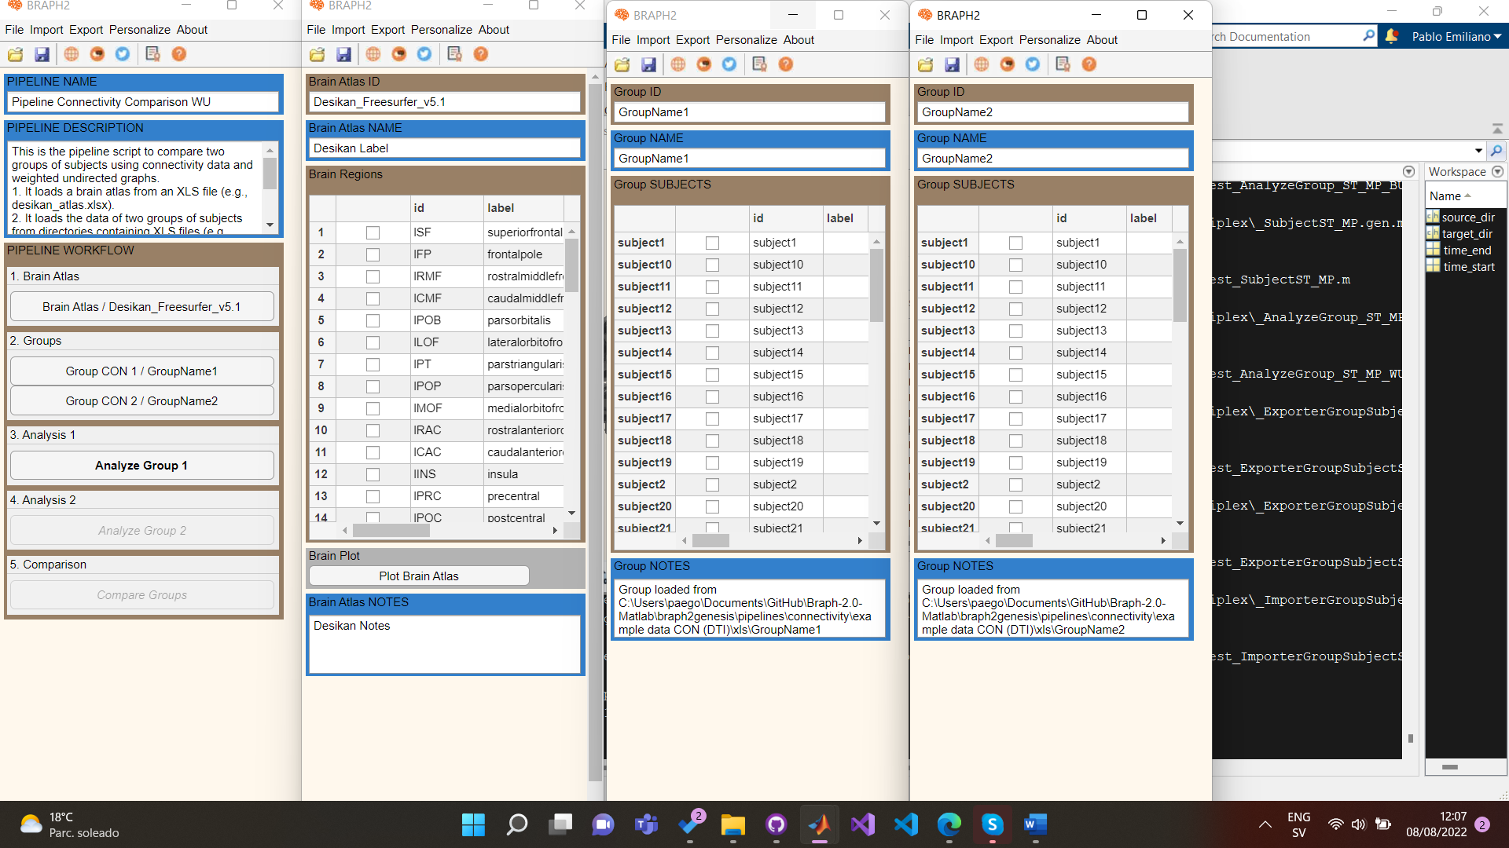
Next, we imported two DTI groups. (You can minimize the windows).
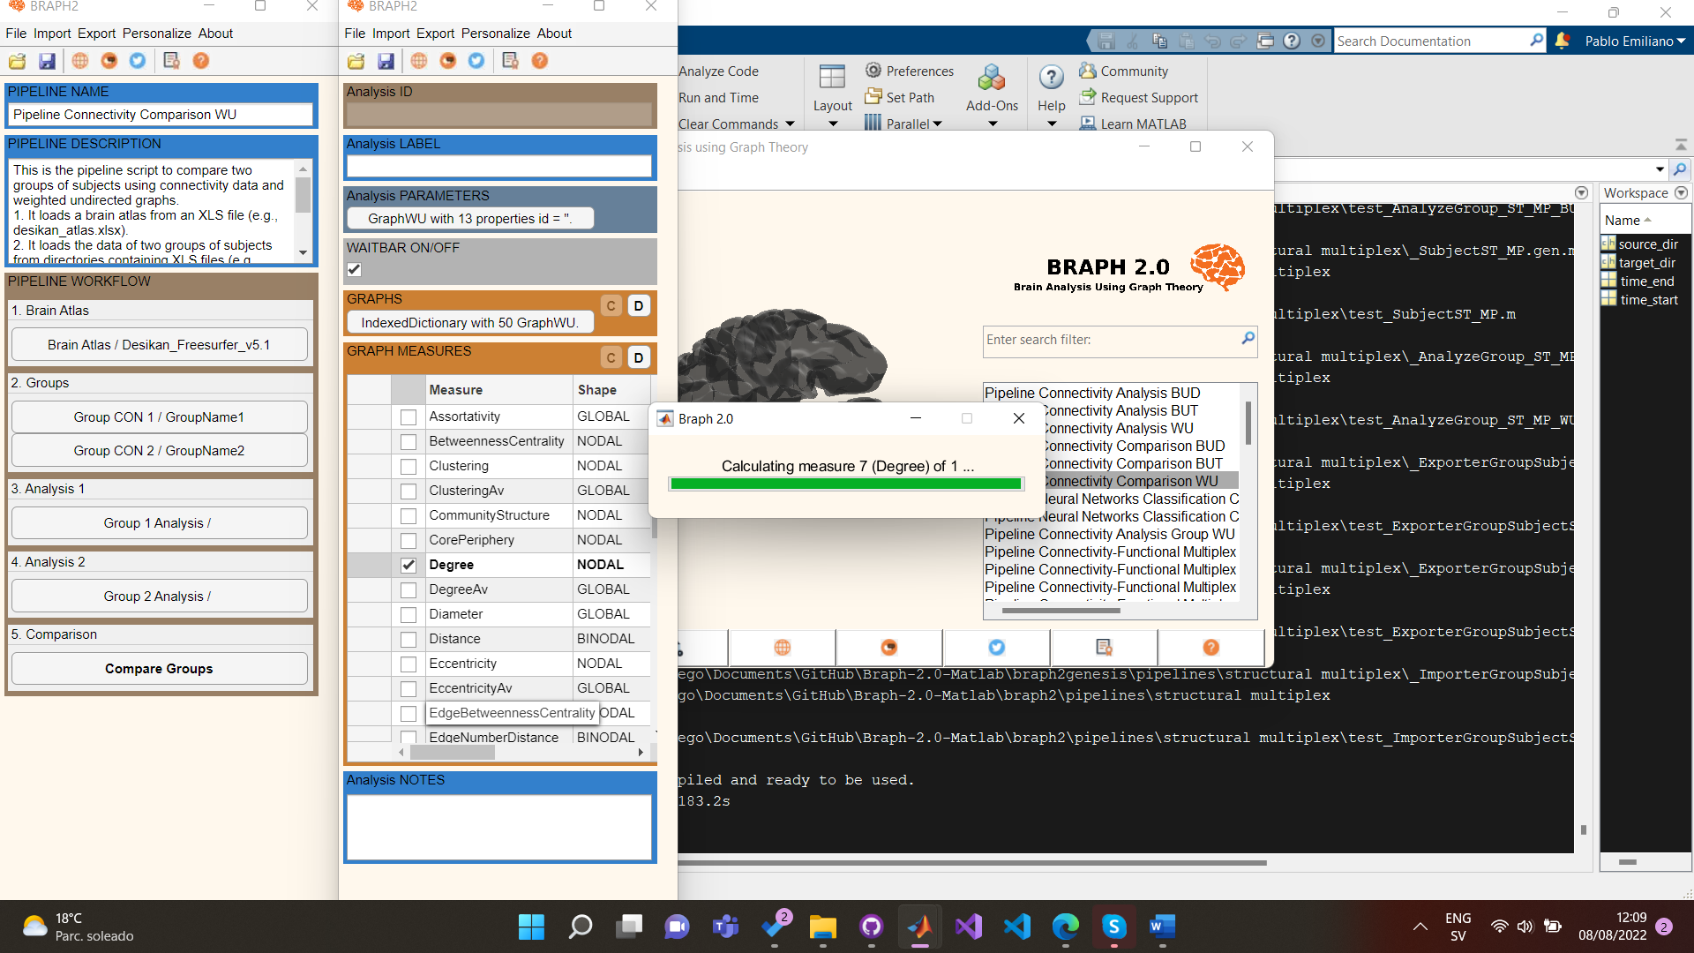
Then we start analysing the data. First start by clicking the C (calculate) button on the section graphs, this will create the respective graphs of the adjacency matrices. Then use the C button in the section Graph Measures. A list will appear with all the possible measures associated to the graph. I will calculate the degree. Select the measure then right-click on the table and click on Calculate Selected Measure. (Feel free to check other functions of the context menu).

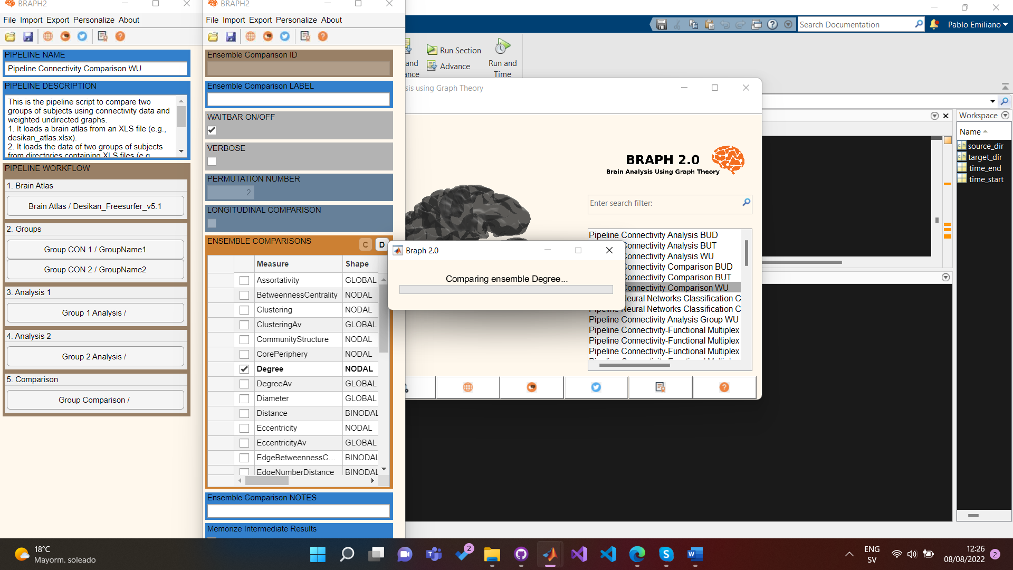
Then after both analyses have concluded go to the comparisons section. BRAPH 2 does a permutation test to compare the analyses. Select the permutation number and the use the C button on the Ensemble Comparisons table.
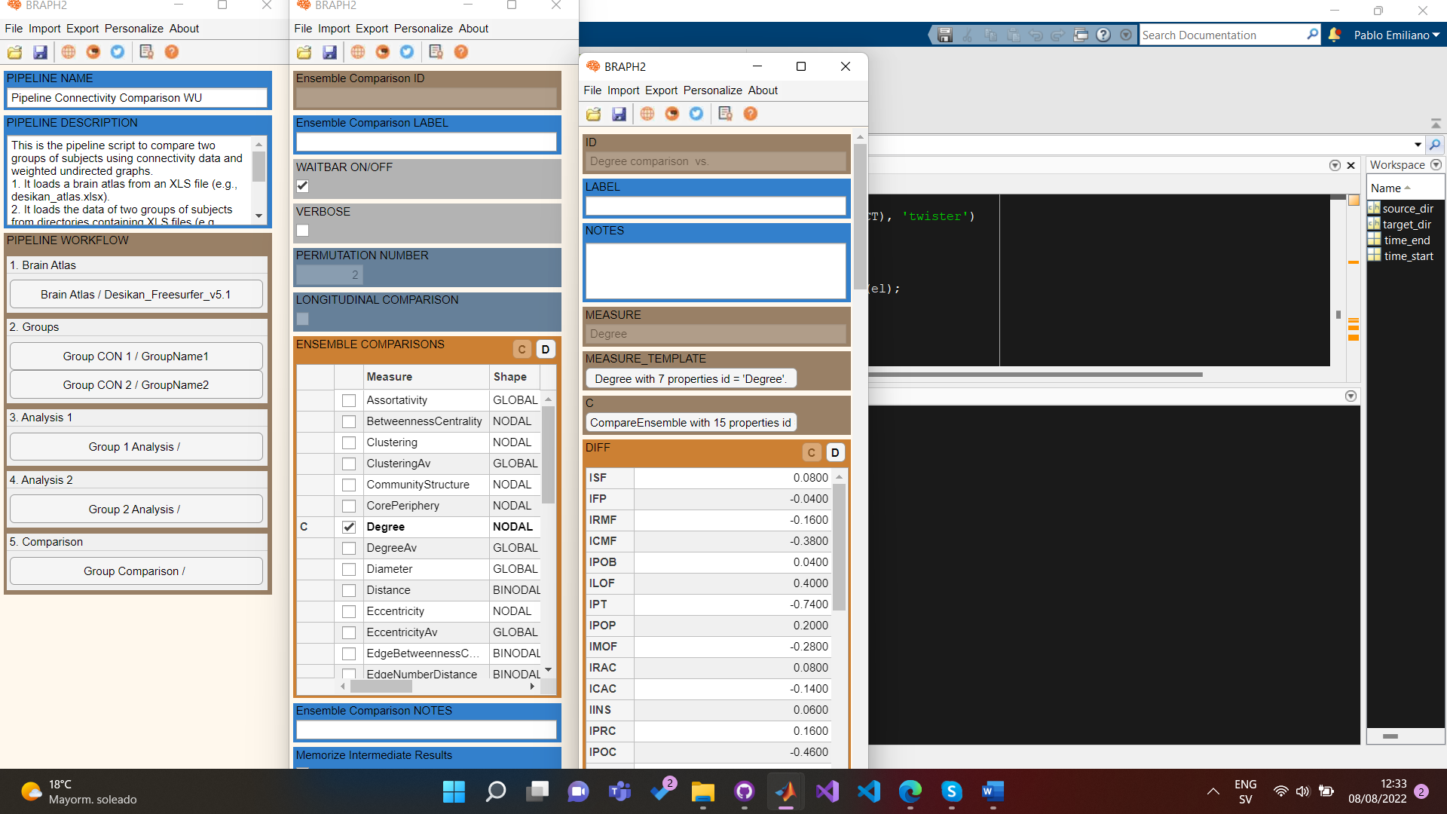
You can visualize the results by right-clicking on the tables and select the different options, here I visualize the data.

